📌 What is Low-Level Design (LLD)?
LLD is the process of designing the internal workings of a system by defining:
- Classes.
- Objects.
- Interfaces.
- Relationships.
- Methods and attributes.
- Internal workflows and interactions.
It bridges the gap between high-level architecture (HLD) and actual implementation.

🧱 Components of LLD

1. Class Diagrams (UML)

2. Object-Oriented Design (OOD).

3. Design Principles

4. Design Patterns

5. Interface Design

Example: LLD of a Parking Lot System

⚙️ Features:
- Multiple parking lots
- Different vehicle types (car, bike, truck)
- Entry and exit gates
- Ticketing
- Payment
Class | Responsibility
ParkingLot | Manages floors, entry/exit gates.
ParkingFloor | Contains parking spots
ParkingSpot | Allocated to vehicles
Vehicle | Superclass for Car, Bike, Truck
Ticket | Issued at entry
Payment | Handles fee calculation
DisplayBoard | Shows free spots
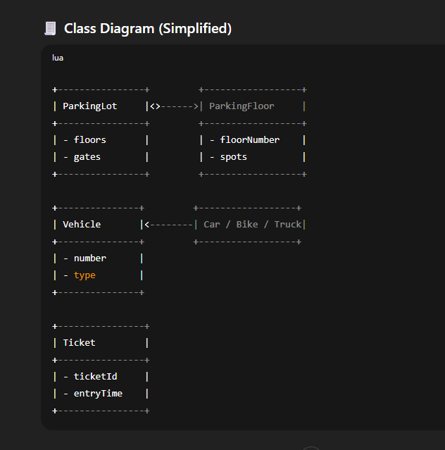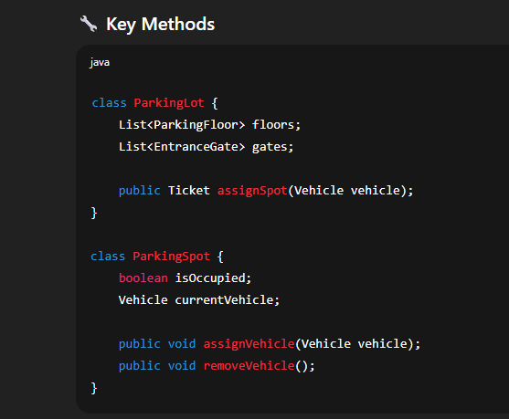
Aspect | LLD (Low-Level Design) | DSA (Data Structures & Algorithms)
Focus | Designing the structure of systems and classes | Solving problems using optimal data structures & logic
Purpose | To build scalable, maintainable software architecture | To build efficient and performant code
Key Concepts | OOP, SOLID principles, Design Patterns, UML | Arrays, Trees, Graphs, HashMaps, Recursion, etc.
Output | Class diagrams, Interfaces, Component interactions | Functions/algorithms with optimal time & space complexity

🔷 What is HLD (High-Level Design)?
High-Level Design (HLD) refers to the overall system architecture that outlines how the components of a software system interact with each other from a bird's eye view. It's like creating a blueprint before constructing a building.
Feature | HLD (High-Level Design) | LLD (Low-Level Design)
Purpose | Shows system's structure and external communication | Shows internal details of each module/class
Scope | System architecture, modules, services, databases | Class design, methods, relationships, data flow
Focus | What components exist & how they interact | How each component is implemented
Concept | Purpose | Focus
DSA (Data Structures & Algorithms) | Solving logical problems efficiently | Arrays, Trees, Graphs, Sorting, Searching, etc.
LLD (Low-Level Design) | Designing code structure | Classes, methods, design patterns (e.g., Singleton, Factory)
HLD (High-Level Design) | Architecting large systems | Components, APIs, databases, communication, scalability

🔄 Real-Life Flow Example:
“Design a parking lot system” (System Design Question)
- HLD: Define modules like Entry, Exit, Payment, Slot Assignment
- LLD: Define classes like ParkingSlot, Vehicle, Ticket
- DSA: Use a PriorityQueue or HashMap to assign nearest free s
NOTE : DSA IS BRAIN OF AN APPLICATION WHILE LLD IS SKELTON OF APPLICATION

✅ What is a UML Diagram?
UML (Unified Modeling Language) diagram is a standard way to visualize the design of a software system. It helps developers, architects, and stakeholders understand how the system works at both high and low levels.

🧩 Types of UML Diagrams (14 total, but here are the most important ones):
Category | Diagram Type | Use
Structure | Class Diagram | Shows classes, attributes, methods, and relationships
 | Object Diagram | Snapshot of objects and their links at a point in time
 | Component Diagram | Visualizes software components and dependencies
Behavior | Use Case Diagram | Shows system functions from a user's perspective
 | Sequence Diagram | Shows how object  s interact over time (method calls)
 | Activity Diagram | Represents workflows and business logic
 | State Diagram | Shows how an object changes state based on events

📘 Example: Class Diagram (Most Common in LLD)
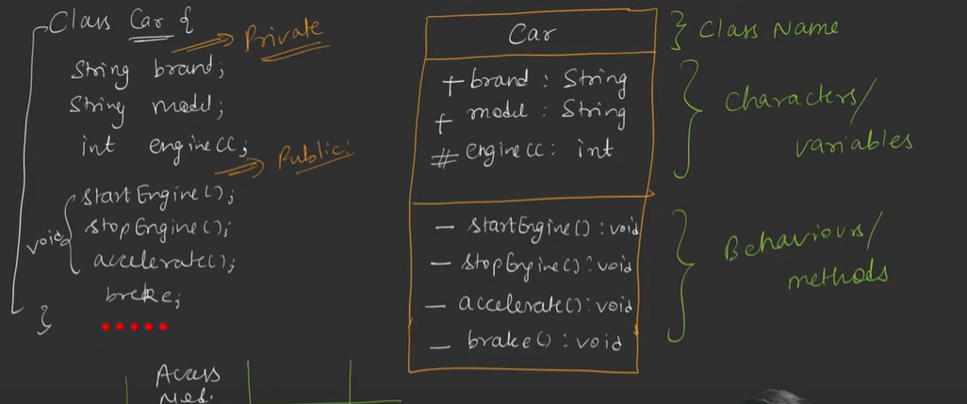
- - = private
- # = protected
- + = public
- This diagram shows a Car class with two fields and two methods.
You can also use <<abstract>> above the class name to explicitly indicate that it’s abstract.

✅ What is Association in UML?
In UML class diagrams, an association represents a relationship between two classes — i.e., how objects of one class relate to objects of another.
Type | Description | Symbol
Association | A general relationship (e.g., a Teacher teaches Students) | Line with optional arrows
Aggregation | A "whole–part" relationship where the part can exist independently | Hollow diamond ◇
Composition | A "strong whole–part" relationship where the part cannot exist independently | Filled diamond ◆
Multiplicity | Indicates how many objects are involved (e.g., 1..*, 0..1, etc.) | Numbers at ends
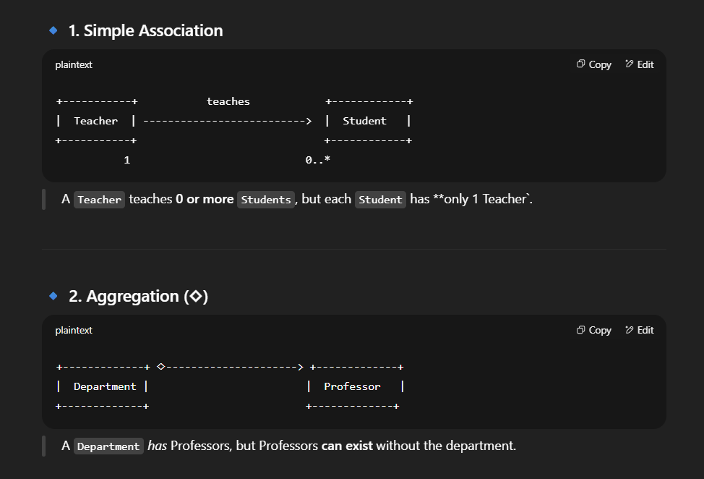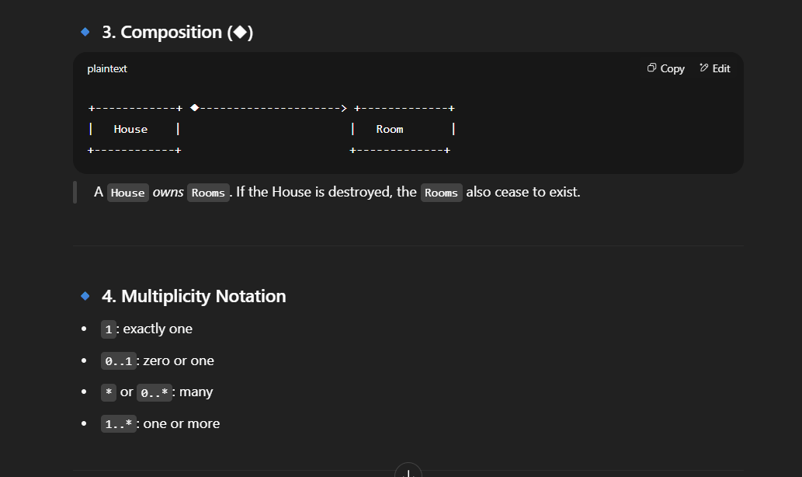
NOTE : Agrregation has a weak relationship if this relationship brakes all the entities can exist independently
But in composition there is a strong relationship on braking enity cant exist independently.
create a class diagram of electric car and manual car relates them with composition.
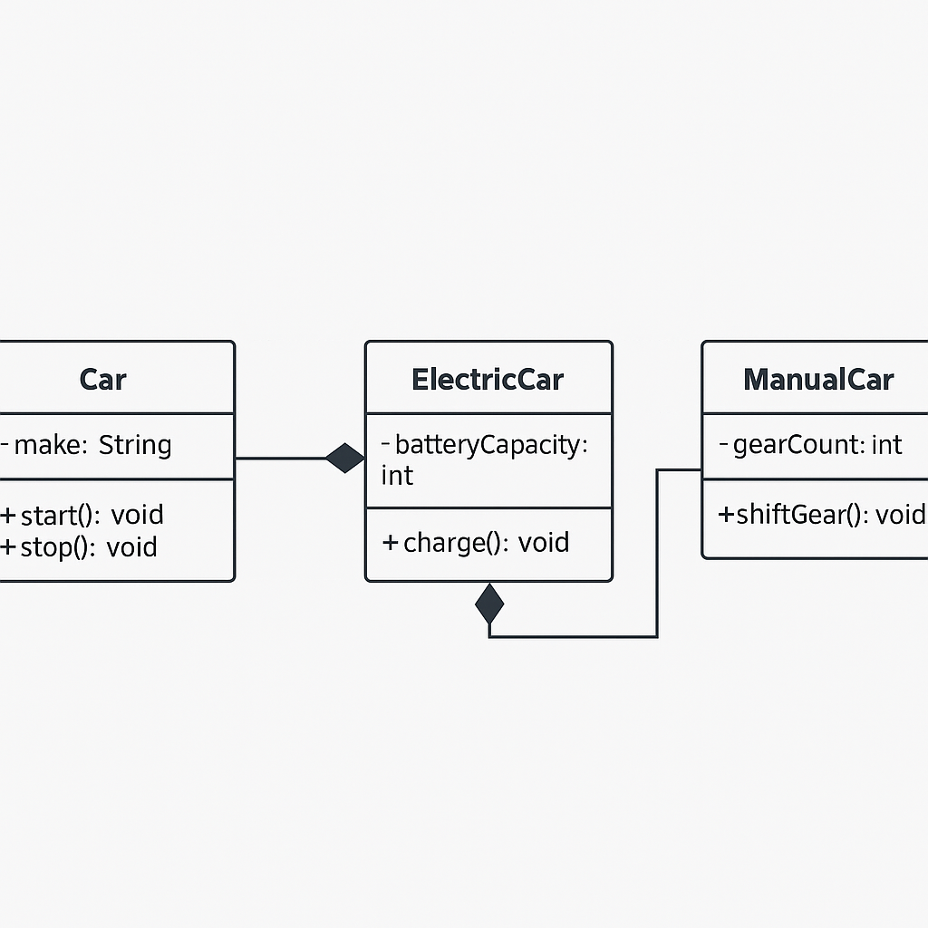
Composition: Owns a Battery object (filled diamond ◆).
- Battery cannot exist without the Electric-Car.
Composition: Owns a Gearbox object (filled diamond ◆).
- Gearbox cannot exist without the ManualCar.
SEQUENCE DIAGRAM
A Sequence Diagram is a type of UML (Unified Modeling Language) diagram that shows how objects interact in a specific sequence of time. It focuses on message passing between objects or components to perform a function or use case.

✅ Key Elements of a Sequence Diagram:
Element | Description
Actors/Objects | Participants in the interaction (e.g., User, Car, System)
Lifelines | Vertical dashed lines representing the life of each object during the scenario
Messages | Horizontal arrows indicating communication (method calls, responses, etc.)
Activation Bars | Thin rectangles on lifelines showing when an object is active (processing a task)
Return Messages | Dotted lines showing responses from one object to another
In a UML Sequence Diagram, messages are the arrows that represent communication between objects or components. These messages show what is being called, who is calling it, and in what order.

✅ Types of Messages:
Type | Symbol / Line Style | Description
Call Message | Solid arrow → | Represents a method call from one object to another
Return Message | Dotted arrow ↩︎ | Represents a return value or response after a method call
Create Message | Solid arrow + <<create>> | Shows that an object is being created
Destroy Message | Solid arrow + <<destroy>> | Shows that an object is being destroyed
Self Message | Arrow that loops back | Represents an object calling one of its own methods
Asynchronous Message | Solid arrow with open arrowhead | Used when the sender does not wait for a reply

Example of sequence diagram for withdraw cash by user
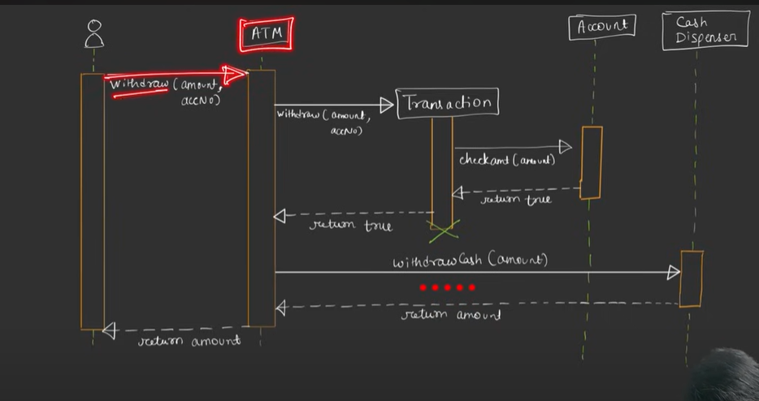
SOLID Design Principles
The SOLID Design Principles are five key principles in object-oriented programming that help developers create systems that are:
- Scalable
- Maintainable
- Flexible
- Robust
Principle | Full Form | Meaning
S | Single Responsibility Principle (SRP) | A class should have only one reason to change — it should only do one job.
O | Open/Closed Principle (OCP) | Software entities should be open for extension but closed for modification.
L | Liskov Substitution Principle (LSP) | Objects of a superclass should be replaceable with objects of a subclass without breaking the app.
I | Interface Segregation Principle (ISP) | Don’t force a class to implement unused interfaces; prefer small, specific interfaces.
D | Dependency Inversion Principle (DIP) | High-level modules should not depend on low-level modules. Both should depend on abstractions.

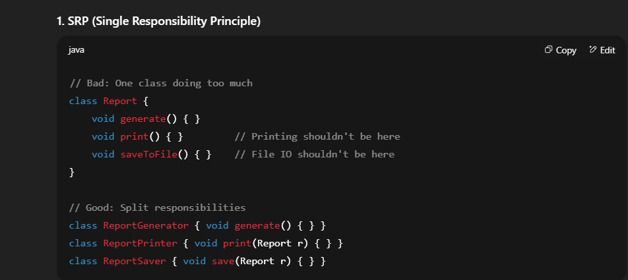
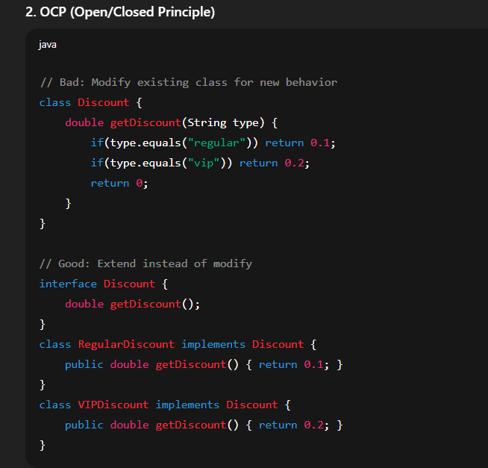
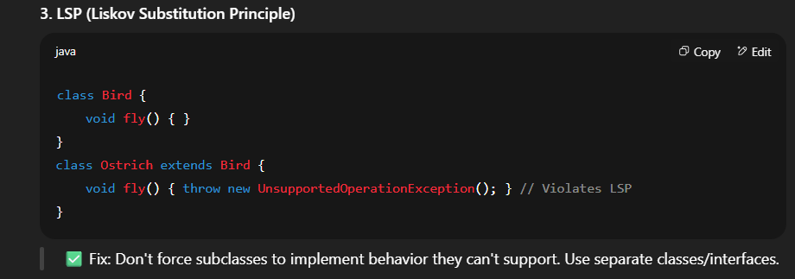
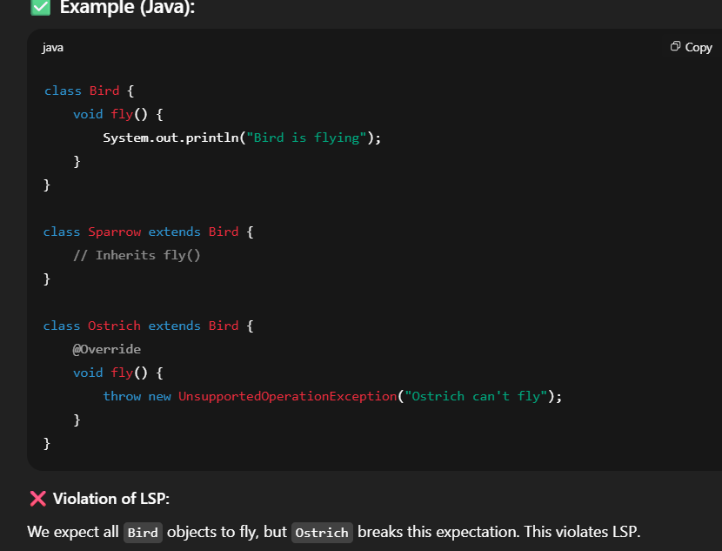
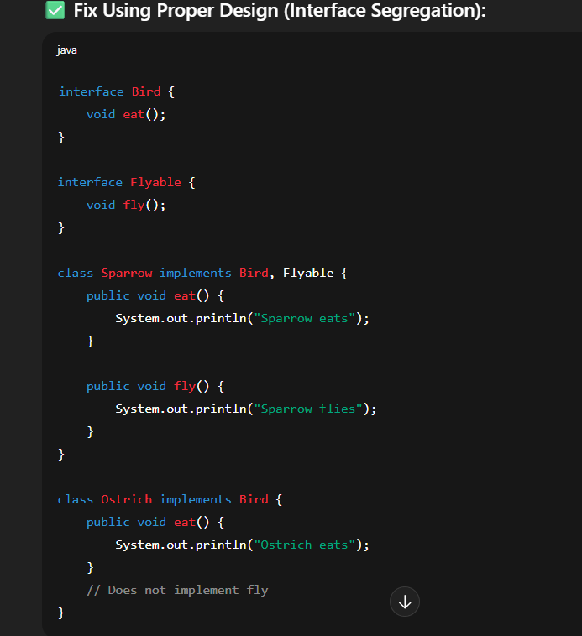
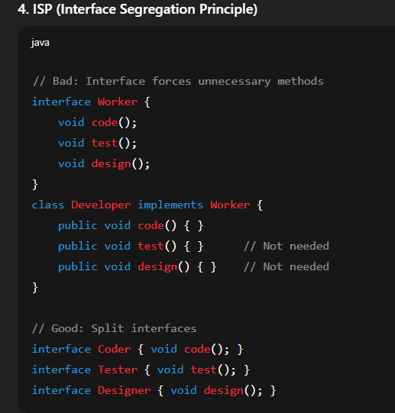
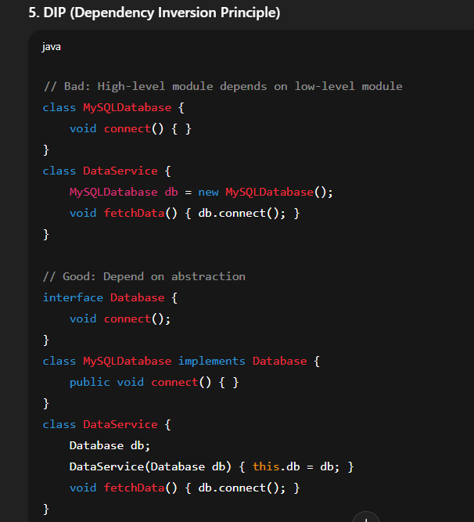
BUILD GOOGLE DOCS : A real world project
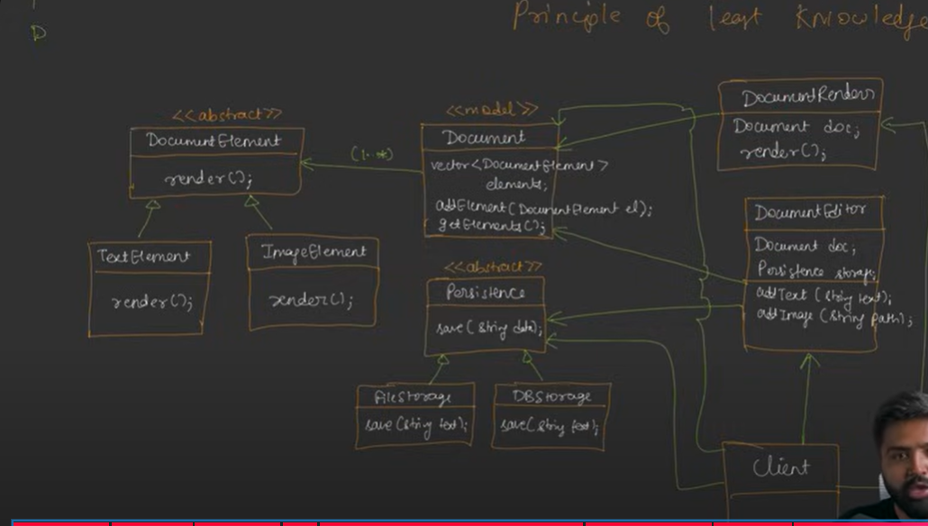
Strategy Design Pattern
In System Design, the Strategy Design Pattern is a behavioral design pattern used to define a family of algorithms (or behaviors), encapsulate each one, and make them interchangeable without changing the code that uses them.
It allows the algorithm/behavior to vary independently from the clients that use it.

🔧 2. When to Use Strategy Pattern in System Design?
- When you want to switch between multiple behaviors at runtime.
- When you have multiple algorithms for a single task.
- When using a lot of if-else or switch conditions based on behavior.
- When adding new algorithms without changing existing code (Open/Closed Principle).
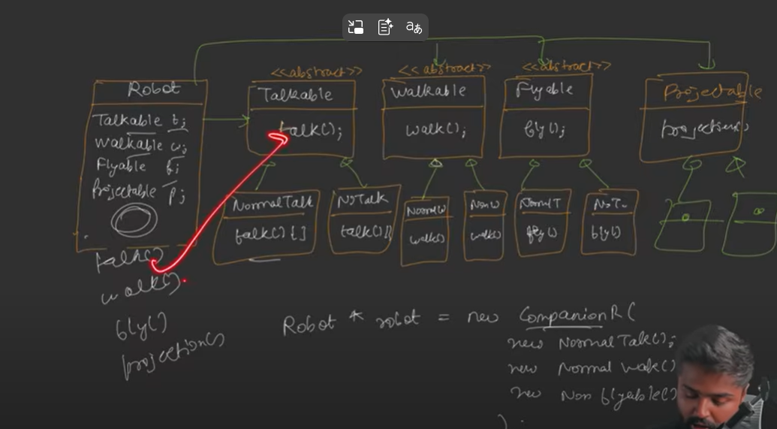
Example of payment
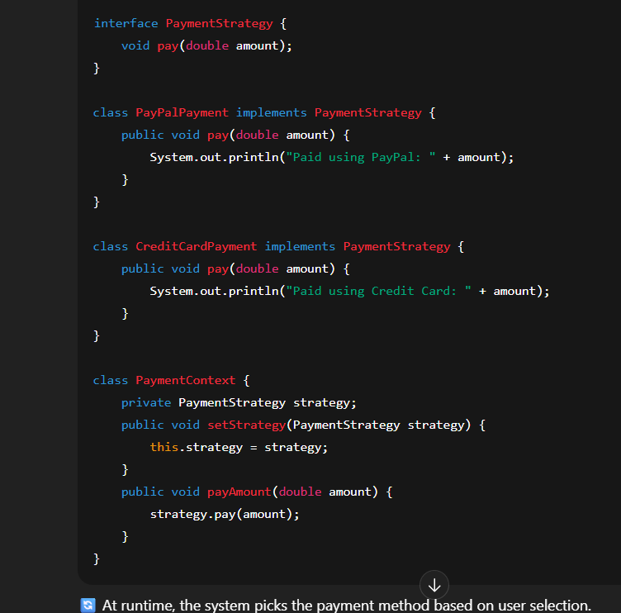

Factory Design Pattern
The Factory Pattern defines an interface for creating an object, but lets subclasses or a factory class decide which class to instantiate.
It promotes loose coupling by eliminating the need to bind application-specific classes into your code.
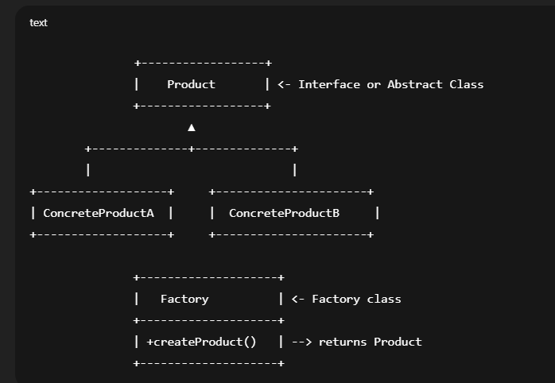
Real world analogy NOATIFICATION SYSTEM
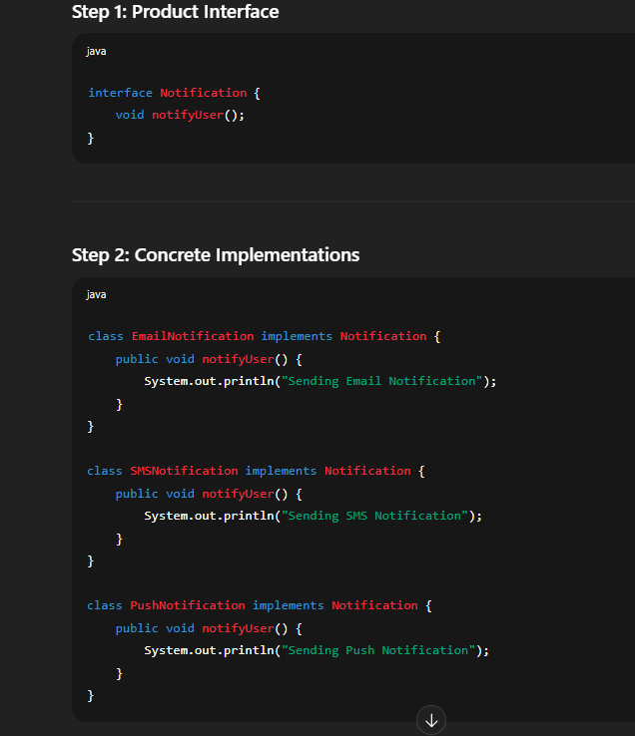
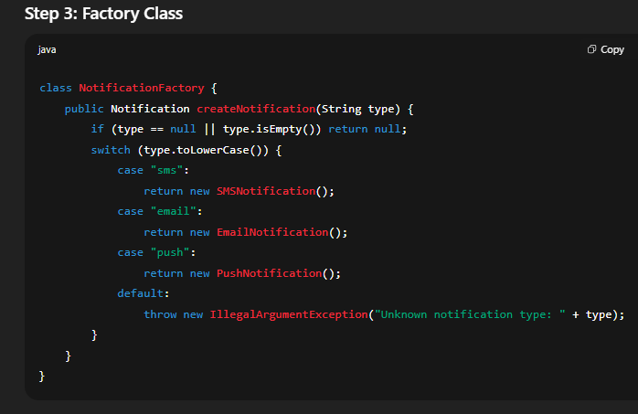
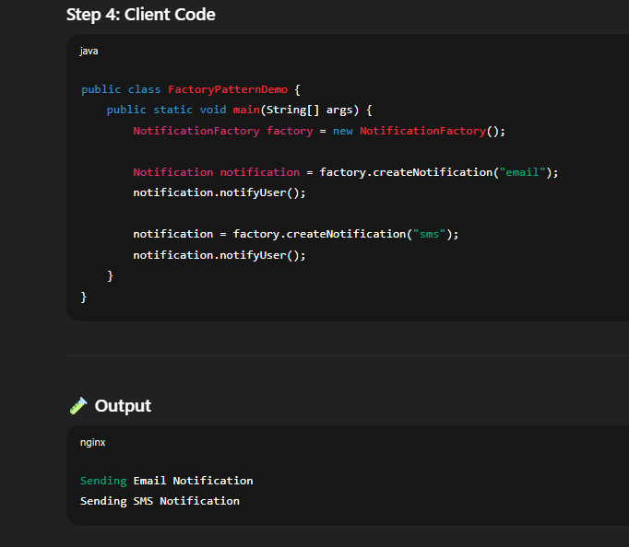
Benefit | Description
✅ Encapsulation | Hides object creation logic.
✅ Loose Coupling | Client is decoupled from concrete classes.
✅ Open/Closed Principle | New types can be added without modifying client code.
✅ Centralized Object Creation | Easier to maintain and scale.

Singleton Design Pattern
The Singleton Design Pattern is a creational design pattern used to ensure that only one instance of a class exists in the entire application and provides a global access point to that instance.
Feature | Description
Private Constructor | Prevents instantiation from other classes.
Static Variable | Holds the single instance of the class.
Static Method | Provides a global access point to get the instance.
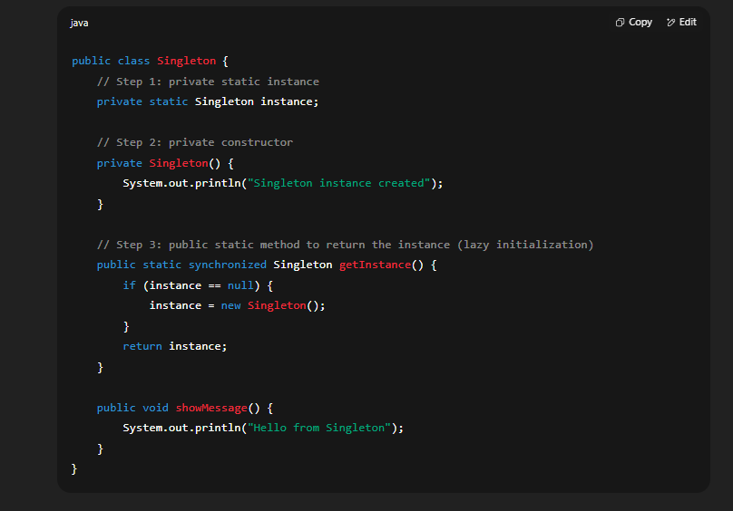
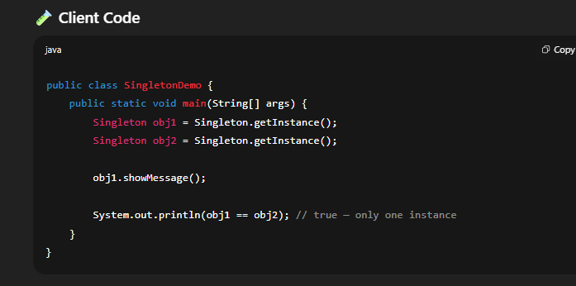
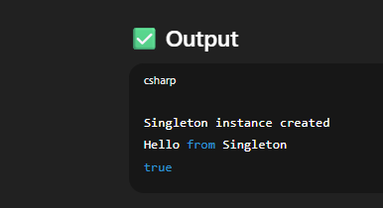
Food delivery app UML Design
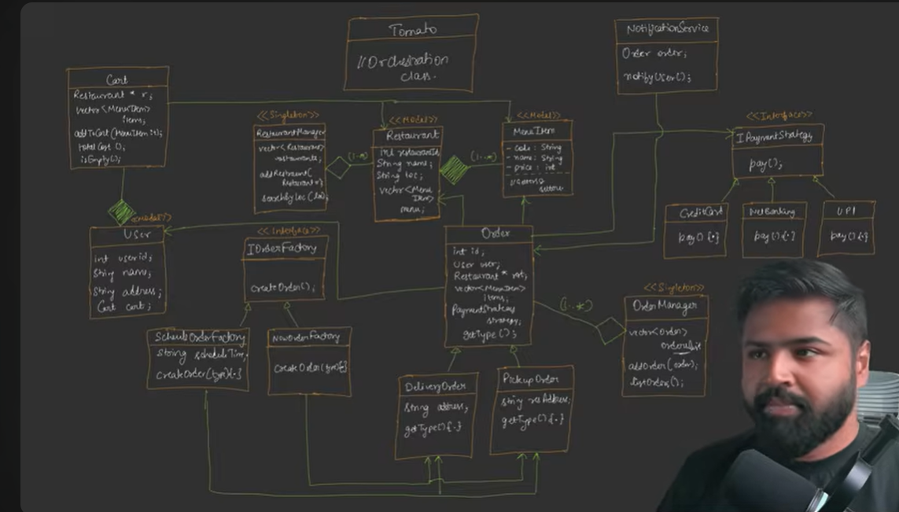
Observer design pattern
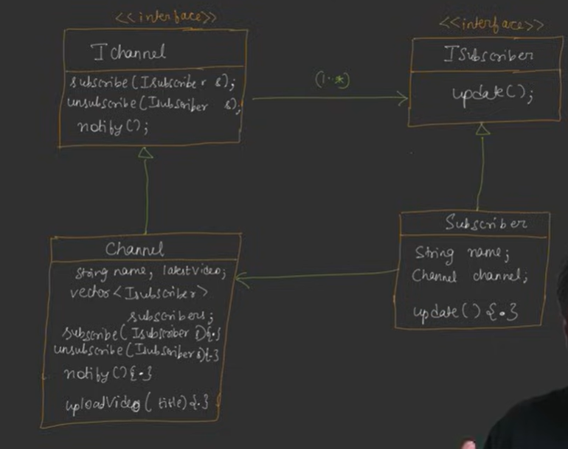
The Observer Design Pattern is a behavioral design pattern that defines a one-to-many dependency between objects. When one object (called the Subject) changes state, all its dependents (called Observers) are notified and updated automatically.

✅ Real-world Analogy
Think of a YouTube Channel (Subject).
People subscribe to it (Observers).
Whenever a new video is uploaded (state changes), all subscribers get a notification.
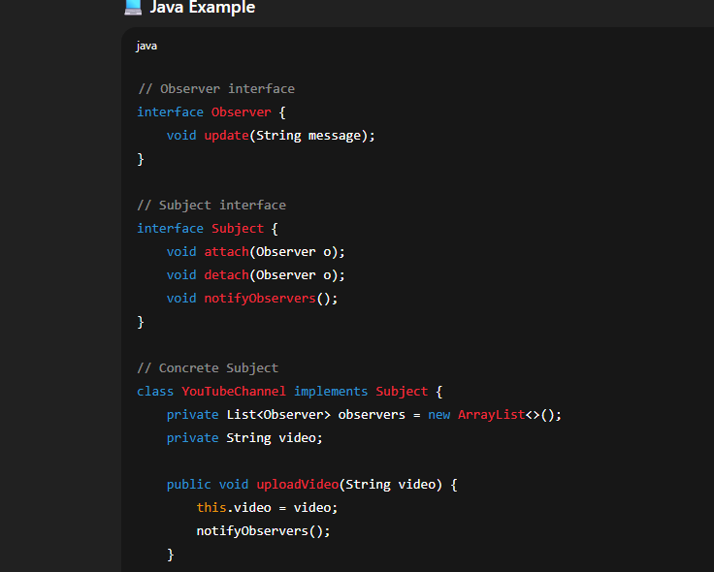
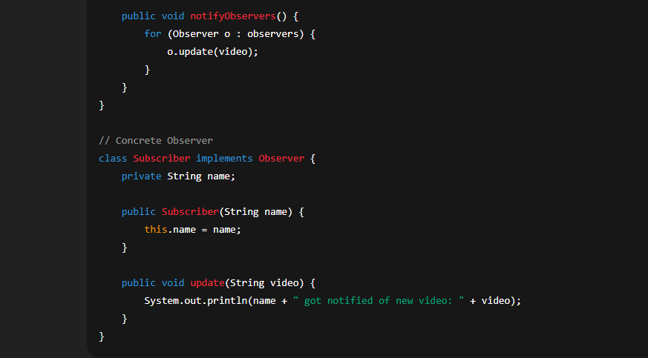

📌 When to Use Observer Pattern
- When multiple objects need to be notified about changes in one object.
- When you want to decouple the subject and observer.
- In event-driven systems (e.g., GUIs, messaging apps).
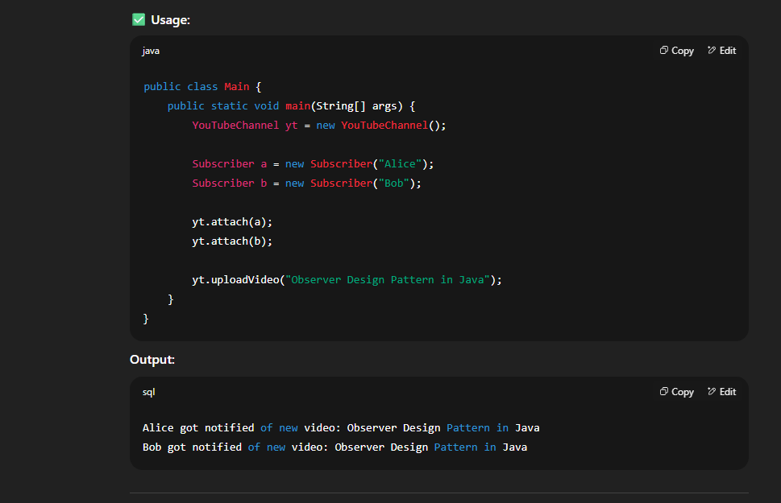
Decorator Design Pattern
The Decorator Design Pattern is a structural design pattern that allows behavior to be added to individual objects, dynamically, without affecting the behavior of other objects of the same class.

📌 When to Use the Decorator Pattern
- To add responsibilities to objects at runtime without subclassing.
- When extending behavior using inheritance is impractical or causes class explosion.
- To follow the Open/Closed Principle (open for extension, closed for modification).

✅ Real-world Analogy
Imagine a coffee shop. You can order a plain coffee, or decorate it with milk, sugar, or whipped cream.
These additions (decorators) wrap around the core object (coffee) without changing its structure.
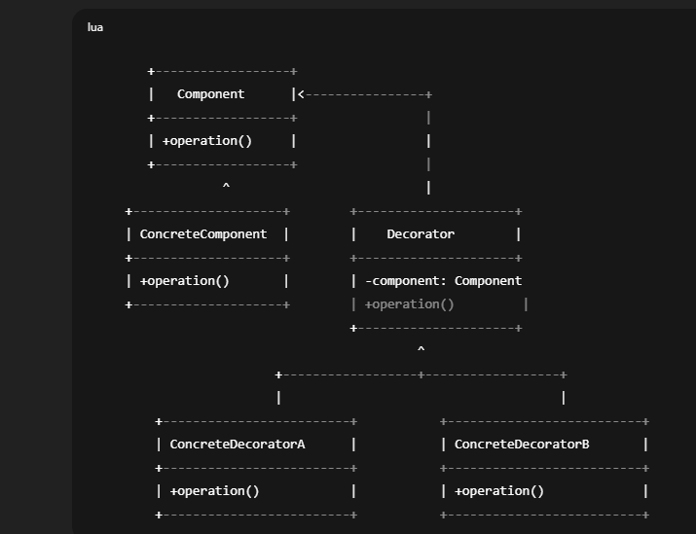
Design notification engine
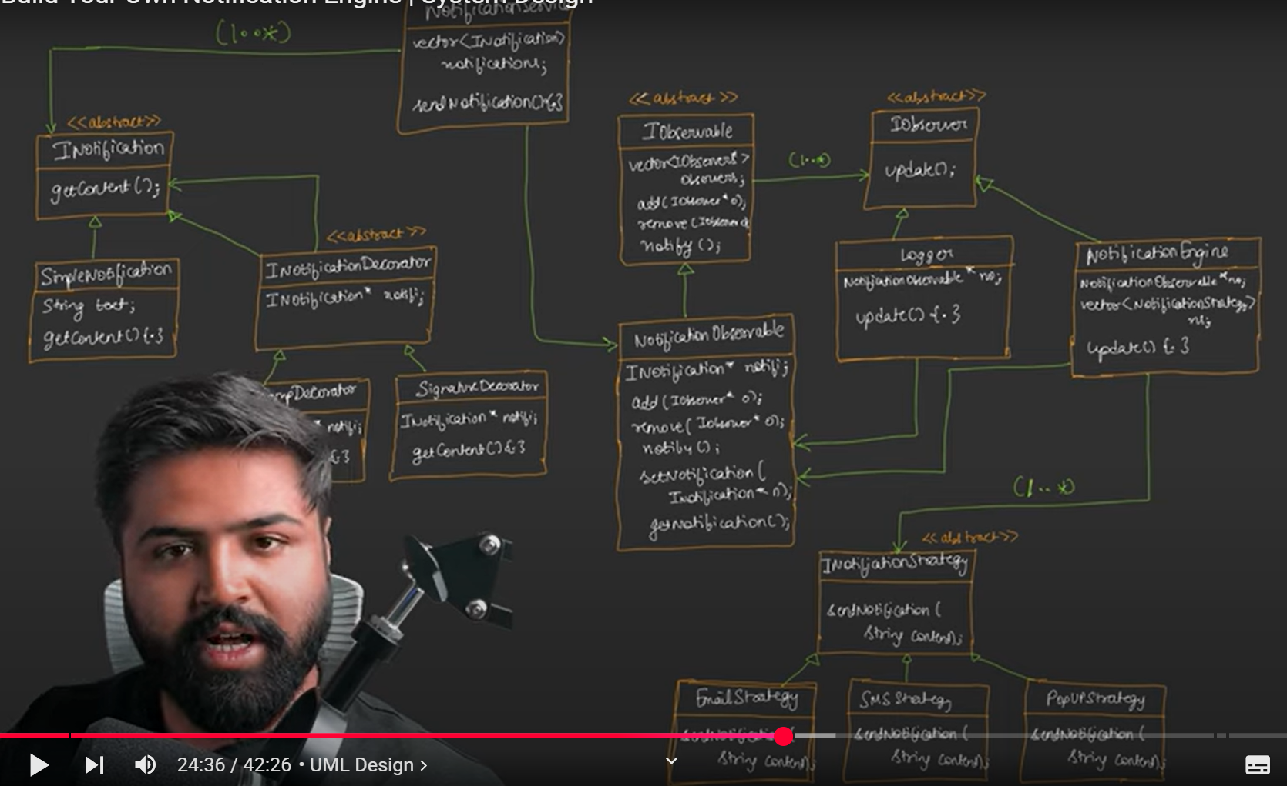
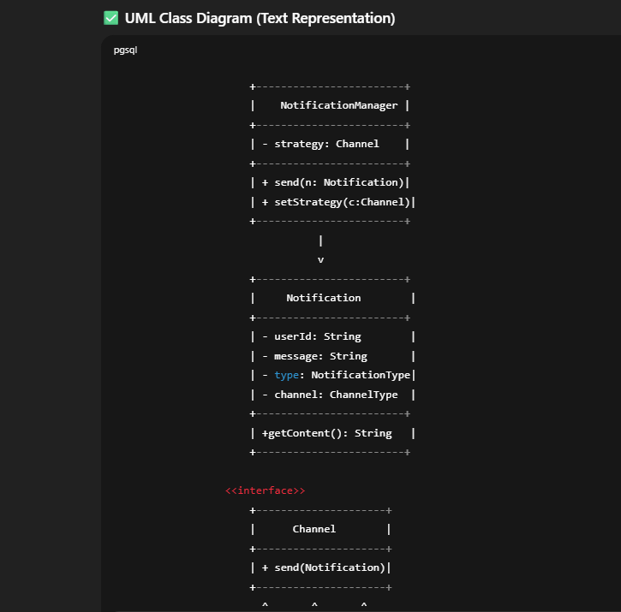
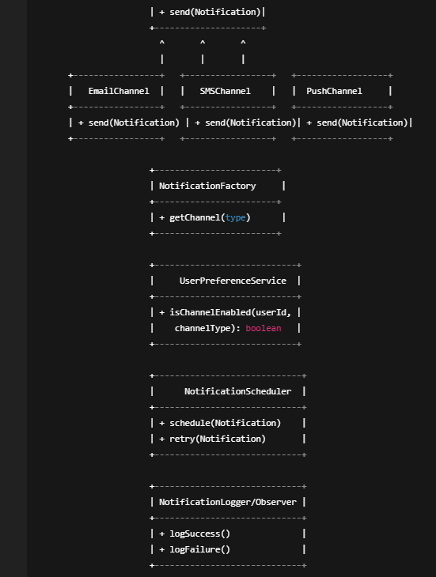
Class / Interface | Responsibility
NotificationManager | Entry point; uses Strategy to send notification.
Notification | Model holding message, type, userId, etc.
Channel (interface) | Defines method send(Notification)
EmailChannel | Sends email via provider like SendGrid
SMSChannel | Sends SMS via Twilio or similar
PushChannel | Sends mobile/web push
NotificationFactory | Returns correct Channel implementation
UserPreferenceService | Checks if user has opted for a given channel
NotificationScheduler | Handles retries, scheduling, DLQ
NotificationLogger | Observer/logger for analytics, failure tracking

Pattern | Where
Strategy | NotificationManager uses different Channel objects
Factory | NotificationFactory provides correct channel
Observer/Logger | Logs notification delivery
Singleton (optional) | For services like Scheduler, Logger if needed

Command Design Pattern
The Command Design Pattern is a behavioral design pattern used in system design and software architecture to encapsulate a request as an object. This allows you to parameterize clients with different requests, delay or queue requests, and support undoable operations.

🔷 Real-World Analogy
Think of a TV remote control:
- Button = Command (e.g., VolumeUpCommand, ChangeChannelCommand)
- TV = Receiver (performs the real action)
- Remote = Invoker (calls commands)

